-docker version

if you get error bellow

“Unable to create: The running command stopped because the preference variable "ErrorActionPreference" or common parameter is set to Stop: Hyper-V was unable to find a virtual switch with name "DockerNAT"

and have check point vpn on your machine you have to uninstall it and restart computer

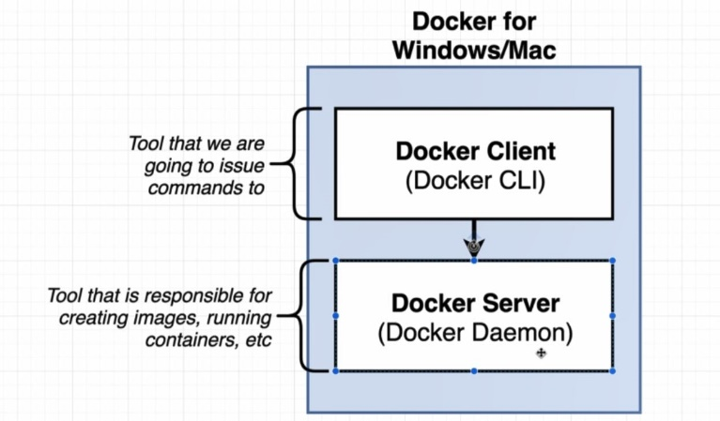

* docker run hello-world

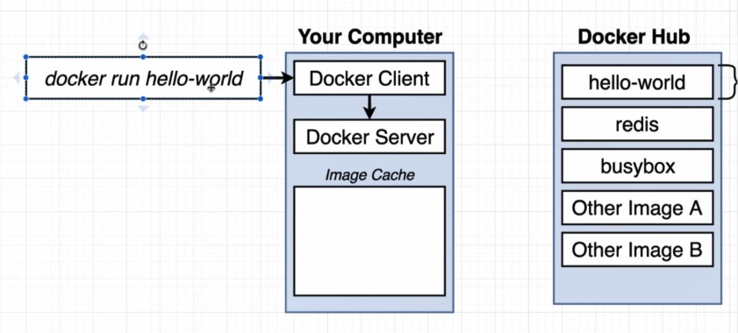

if hello-world image does not exist on local, request it from Docker Hub and save it on Image Cache of local machine.

after download and save image on local we have to create an container:

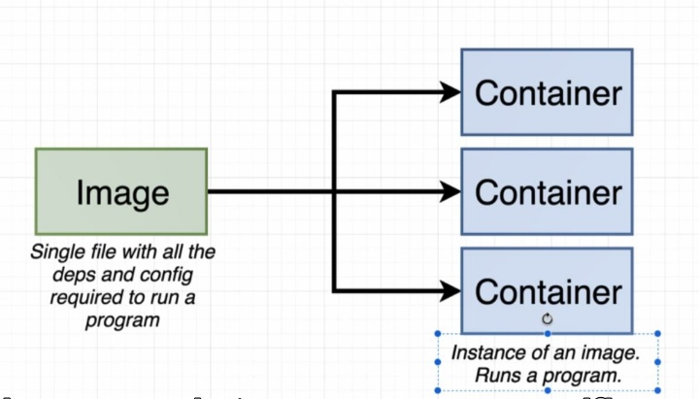

Container is a process or set of processes that have grouping of resources specifically assigned to it

Container is a running process along with a subset of physical resources on your computer there are allocated to that process specifically

By install docker for windows on machine we actually install a Linux virtual machine.

Create and Running a Container from an Image.

* docker run hello-world

\*\* this command run very quickly and then immediately closed down

Container is a process or set of processes that have a grouping of resources specifically assigned to it.

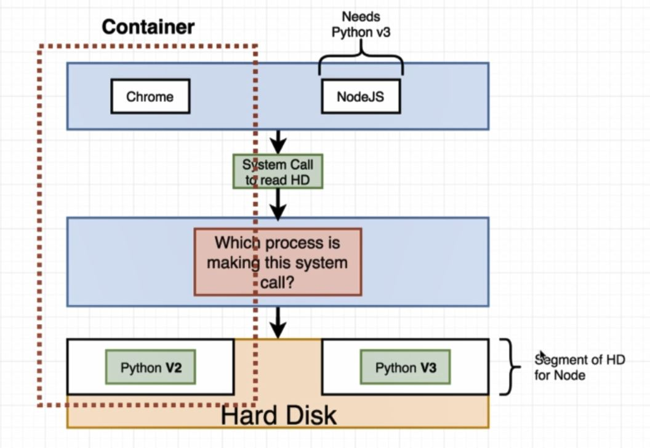

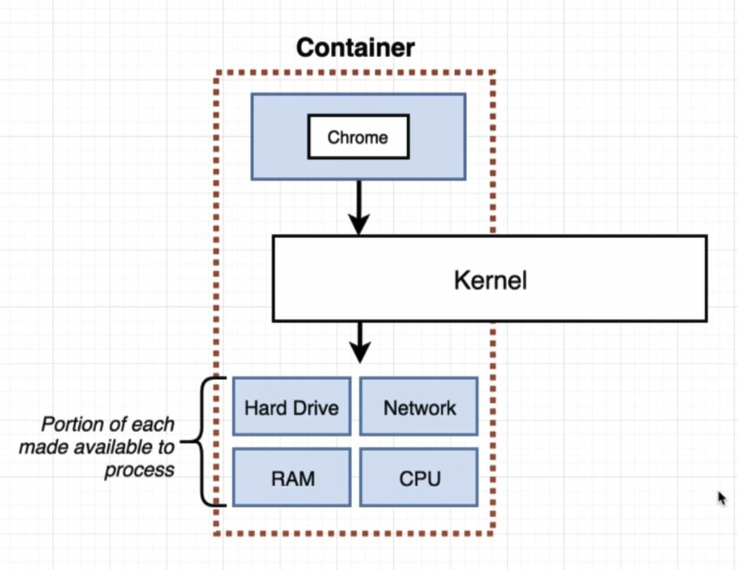

When we talk about image we really talk about a file system snapshot(copy paste of very specific set of directories of files).

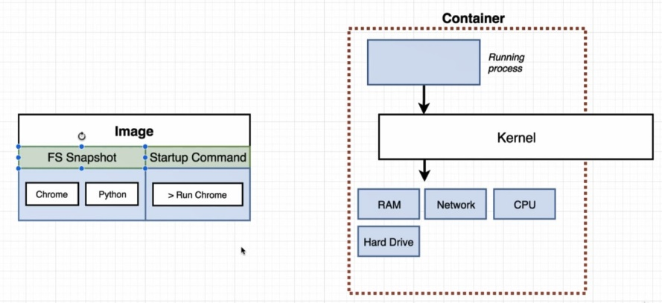

It also has startup command

